Project Design Phase
Solution Architecture

Date | 9 July 2026
Team ID
Project Name | ShopEZ
Maximum Marks | 4 Marks

Solution Architecture:
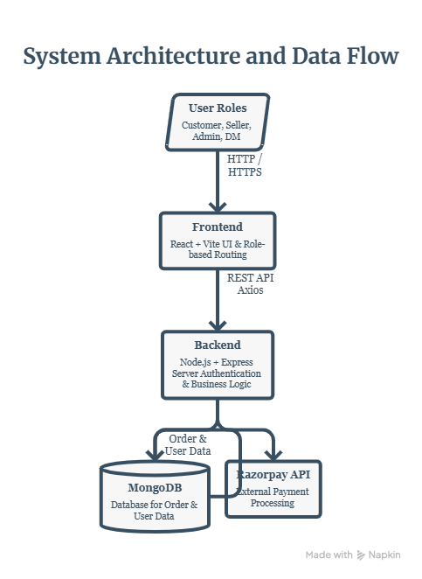

Architecture Description
The architecture consists of four major layers:

Presentation Layer
Developed using React and Vite, this layer provides separate dashboards for customers, sellers, delivery managers, and administrators.

Application Layer
The backend is developed using Node.js and Express.js. It manages authentication, business logic, product management, orders, payments, and user requests through REST APIs.

Data Layer
MongoDB stores user information, products, categories, orders, payments, reviews, and other application data.

External Services
Razorpay is integrated to process secure online payments. Email services are used for password reset and user notifications.

Workflow
- User logs into ShopEZ.
- React sends requests to the Express server.
- Backend validates the request using JWT authentication.
- Required data is stored or retrieved from MongoDB.
- Razorpay handles payment transactions during checkout.
- The server sends the response back to the frontend.
- Users can view updated orders and account information.

Technologies Used
Layer | Technology
Frontend | React, Vite, Bootstrap
Backend | Node.js, Express.js
Database | MongoDB Atlas
Authentication | JWT, bcrypt
Payment | Razorpay
Deployment | Vercel, Render

